**Creating an EC2 instance:**

**Choose AMI:**

* To create EC2 instance, we need to first select the AMI. That could be the amazon AMI or our own designed one as below.

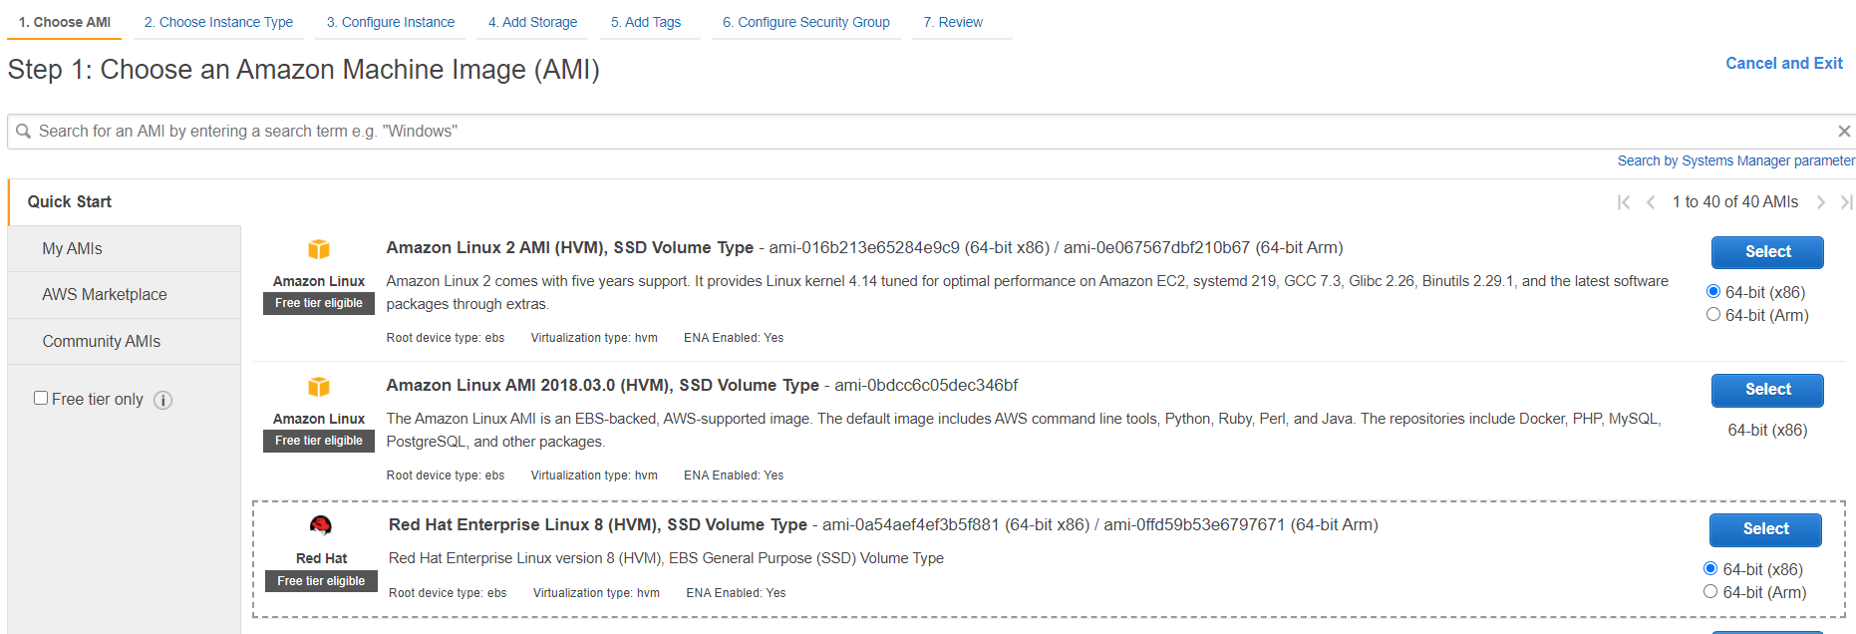

**Instance Type:**

* Then we need to select the instance type based on the requirement.

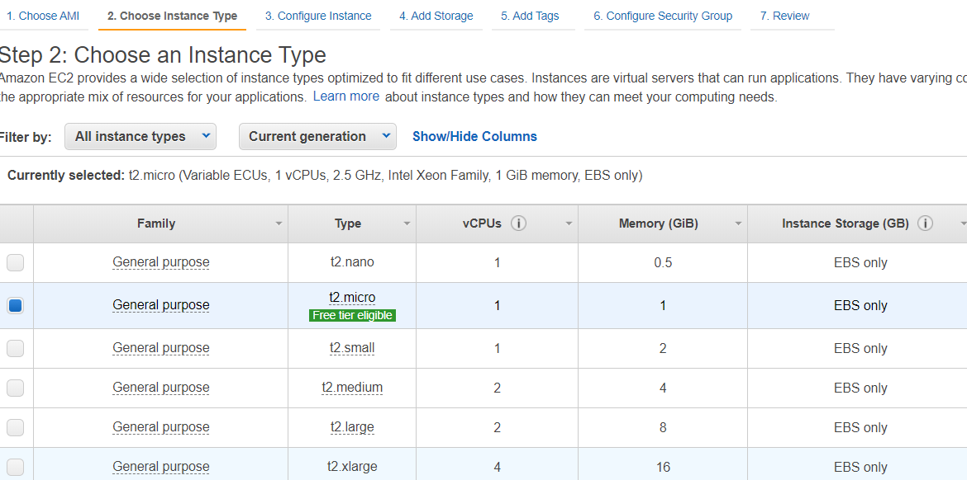

**Configure Instance:**

* Now, we need to give the configuration details as per the requirement.

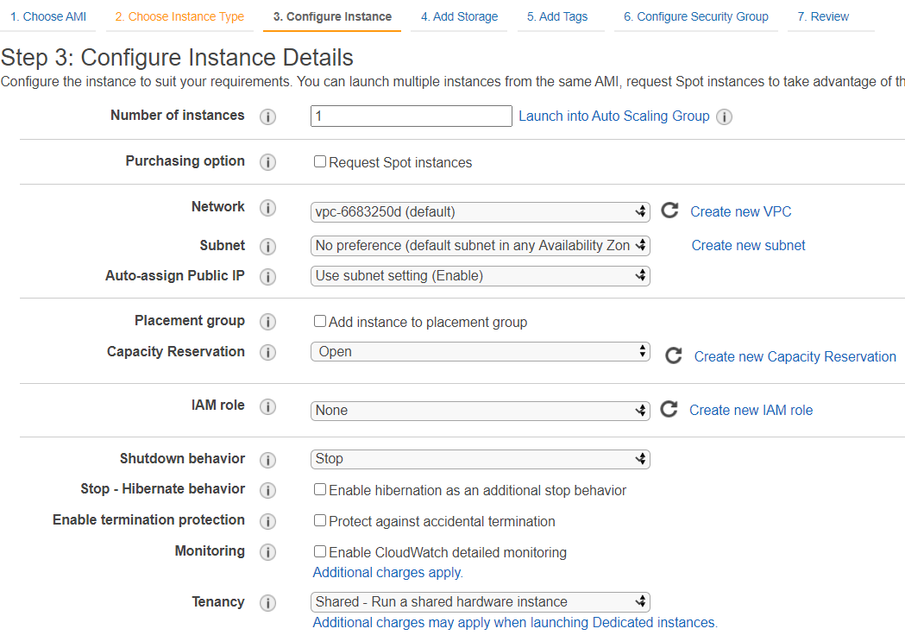

* We give the number of instances we want to create, the vpc & subnet details
* Add the placement groups if any, capacity reservations, IAM roles etc.
* There are two options for shutdown behaviour. One is “stop” and another is “terminate”. If we select stop, it will just stop the server when we do OS-level shutdown. If we select terminate, then it would terminate the instance.

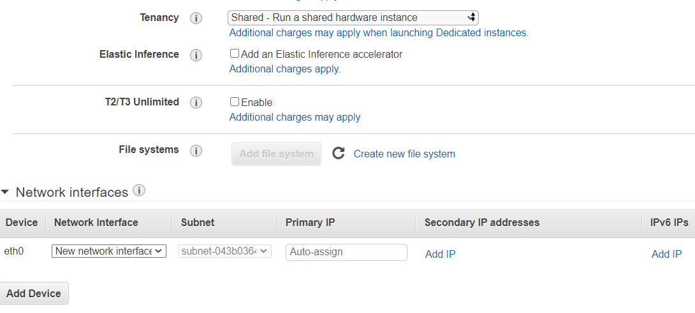

* We can add network interfaces if any or we can add an extra IP as above.

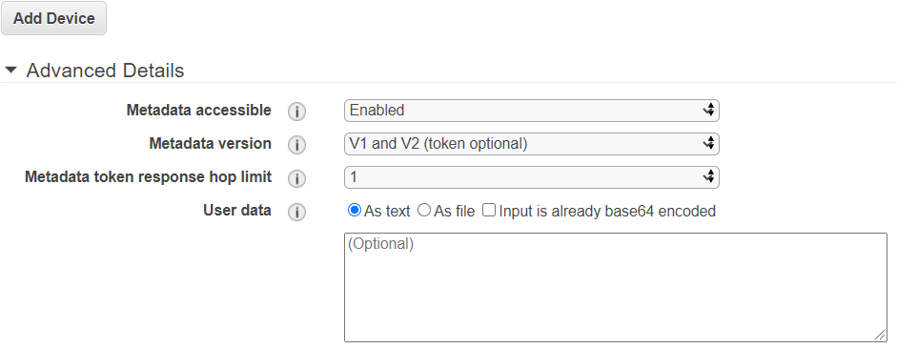

* Then finally, we can give any commands in advanced details section to get executed as below while launching the server

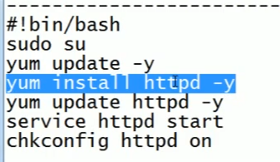

**Add Storage:**

* We can add volumes as below in next step.

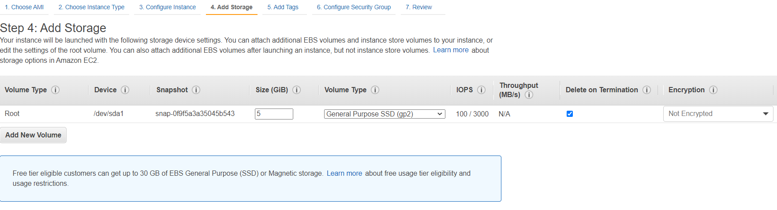

**Add tags:**

* Then tags if we want

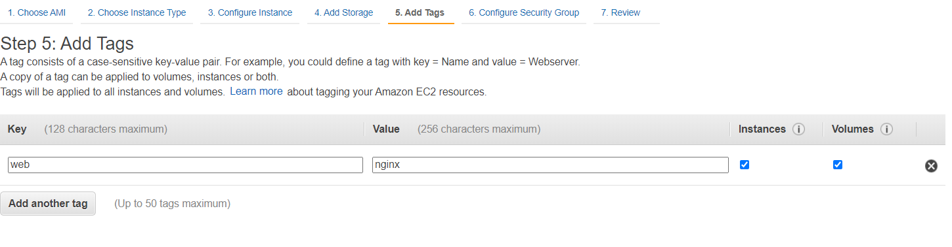

**Security groups:**

* Assign a security group. Either existing one or create a new one.

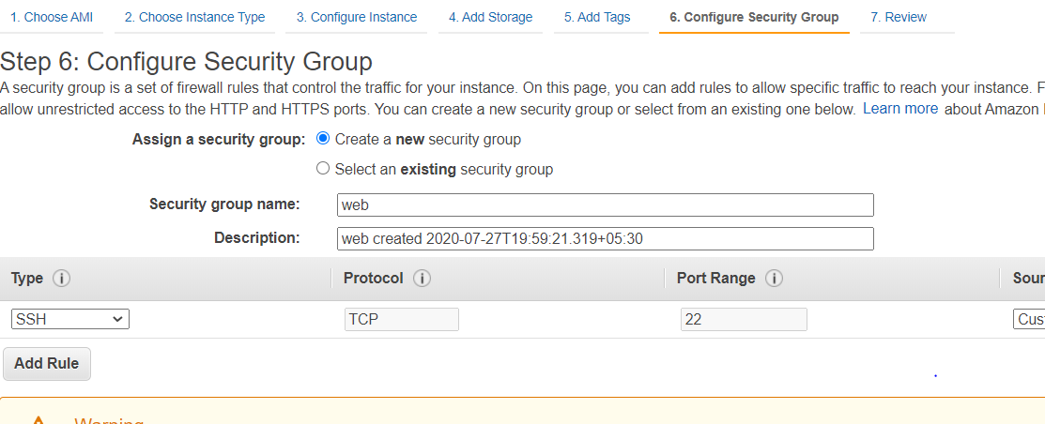

**Review and Launch:**

* Then finally, we can review everything once and launch the instance.

After this, we need to create a key pair or select the existing one for the authentication of the servers, the public key aws stored and private one we need to keep and use it for the authentication of servers.

